Date____________________ 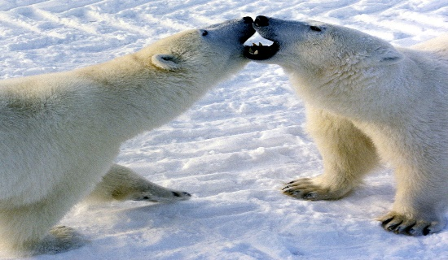
This Photo by Unknown Author is licensed under CC BY-SA

Dear _________________________,

- I remember when we:

- When you were sick,
it was so sad when:

It was so scary when:

- I wish we could have:

- You made me laugh when:

- I liked helping you with:

- The things I miss the most about you are:

- These are the things I hear, see, taste, smell, touch, that remind me of you:

Love, ___________________________

